Centre for Civil Society Seminar Series
CAMPAIGNS YOU NEED TO KNOW ABOUT!
Please join us for a special seminar series on civil society campaigns you need to know about!
The second of these campaigns is the Durban Coalition which works towards strengthening action towards transforming the city into a more just, inclusive and climate resilient place to live.

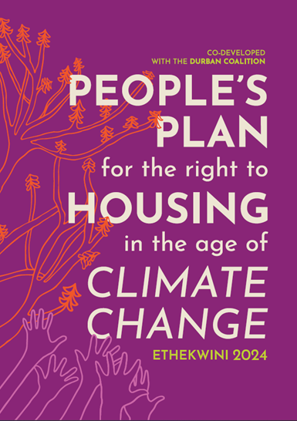

Title: The People’s Plan for the Right to Housing in an Age of Climate Change
Speaker: Kira Erwin
Date: Wednesday, 25 March 2026 – 13:00-14:00
MS Teams Link: https://teams.microsoft.com/meet/37080907414495?p=oDmdH0aO0rhDpCfnlT
About the seminar: The Durban Coalition is a growing nonpolitical coalition of civil society organisations supported by local academia, and other technical experts. Its members represent a range of social movements, environmental and social justice NGOs, community-based organisations, university academics and civic structures such as ratepayers and residents’ associations. Formed in May 2022 in response to the April 2022 climate-induced floods, the Durban Coalition has, based on shared concerns, developed programme of action towards transforming our city into a more just, inclusive and climate resilient place to live.
Responding to climate change requires integrated and holistic planning through participatory and democratic methods. To address this, in 2023, the Durban Coalition initiated a participatory and grounded planning process across different urban sectors and class positions. The objective was to collectively develop a participatory planning process that prioritised the contexts and needs of the most marginalised and vulnerable in the city. The People’s Plan for the Right to Housing in an Age of Climate Change is the culmination of this ground-up process to co-develop the governance arrangements and programmes required to protect the people’s right to housing from continued fossil fuel harms.
Speaker bio:
Kira Erwin works at groundWork, an environmental justice organisation in South Africa. She was previously an Associate Professor at the Durban University of Technology. She is a sociologist and scholar-activist whose work focuses on environmental justice. She is inspired by and learns from the community-based organisations, civil society and social movements she has been fortunate to work with. She also works on Zero Waste in a Just Transition, creative methodologies, and is a member of the secretariat of the Durban Coalition, a civil society coalition working towards a more socially, economically and environmentally just city. She has deep hope in humanity that we can do better in creating a world safer from harm.

