Centre for Civil Society Seminar Series
CAMPAIGNS YOU NEED TO KNOW ABOUT!
Please join us for a special seminar series on civil society campaigns you need to know about!
One of these campaigns is Healthy Living Alliance (HEALA) which advocates for equitable access to affordable, nutritious food in South Africa by building a more just food system in South Africa.
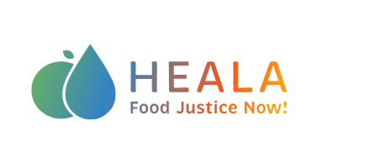

Title: You have a right to know what’s in your food
Speaker: Zukiswa Zimela
Date: Wednesday, 1 April 2026 – 13:00-14:00
MS Teams Link: https://teams.microsoft.com/meet/35313657725252?p=BYdXU9wEA8bOQf0Gtr
About the seminar: We often think of our food as going from the farm to our plates, and many people often believe the food we consume is a choice. In reality, many different and often unseen mechanisms shape what we eat, including agricultural processing, distribution and economic systems as well as government policies. Collectively, all these processes are often referred to as the food system. When food systems don’t work, people’s health pays the price. Because government policy forms a crucial part of South Africa’s food system, HEALA believes hunger, food insecurity and malnutrition are policy choices. The South African government must urgently address entrenched inequities within the food system by enacting legislation to enable a healthy food environment, including strengthening poverty reduction measures and regulating the food and beverage industry to ensure transparency. This is how civil society organisations like HEALA are working to ensure that government is held accountable in protecting ordinary people.
Speaker bio:
Zukiswa Zimela is a communications specialist with fourteen years’ experience in the media and communications space. Having worked in multiple media spaces, her passion lies in advocacy communication and the realization of human rights for all. This fire was sparked during her tenure at IPS Africa, a news wire organization which focuses on advocacy, health and developmental issues for the marginalized across the African continent. Her communication skills come from working across a wide range of media platforms. Zukiswa believes in platforming issues that affect the disenfranchised and giving a voice to the voiceless.

